Aws -IAM
1.Create one IAM user and assign EC2 and S3 full access roles.
- First I have Navigated to IAM service, then clicked on users to create an user
- Enter username
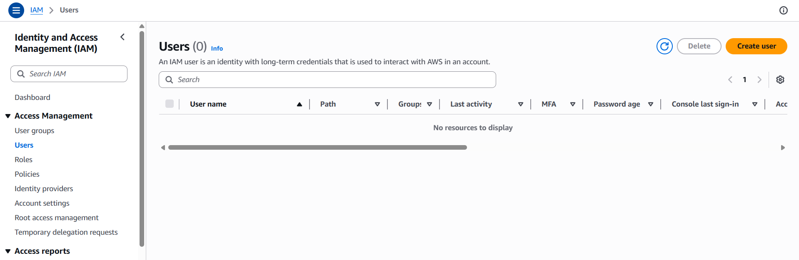
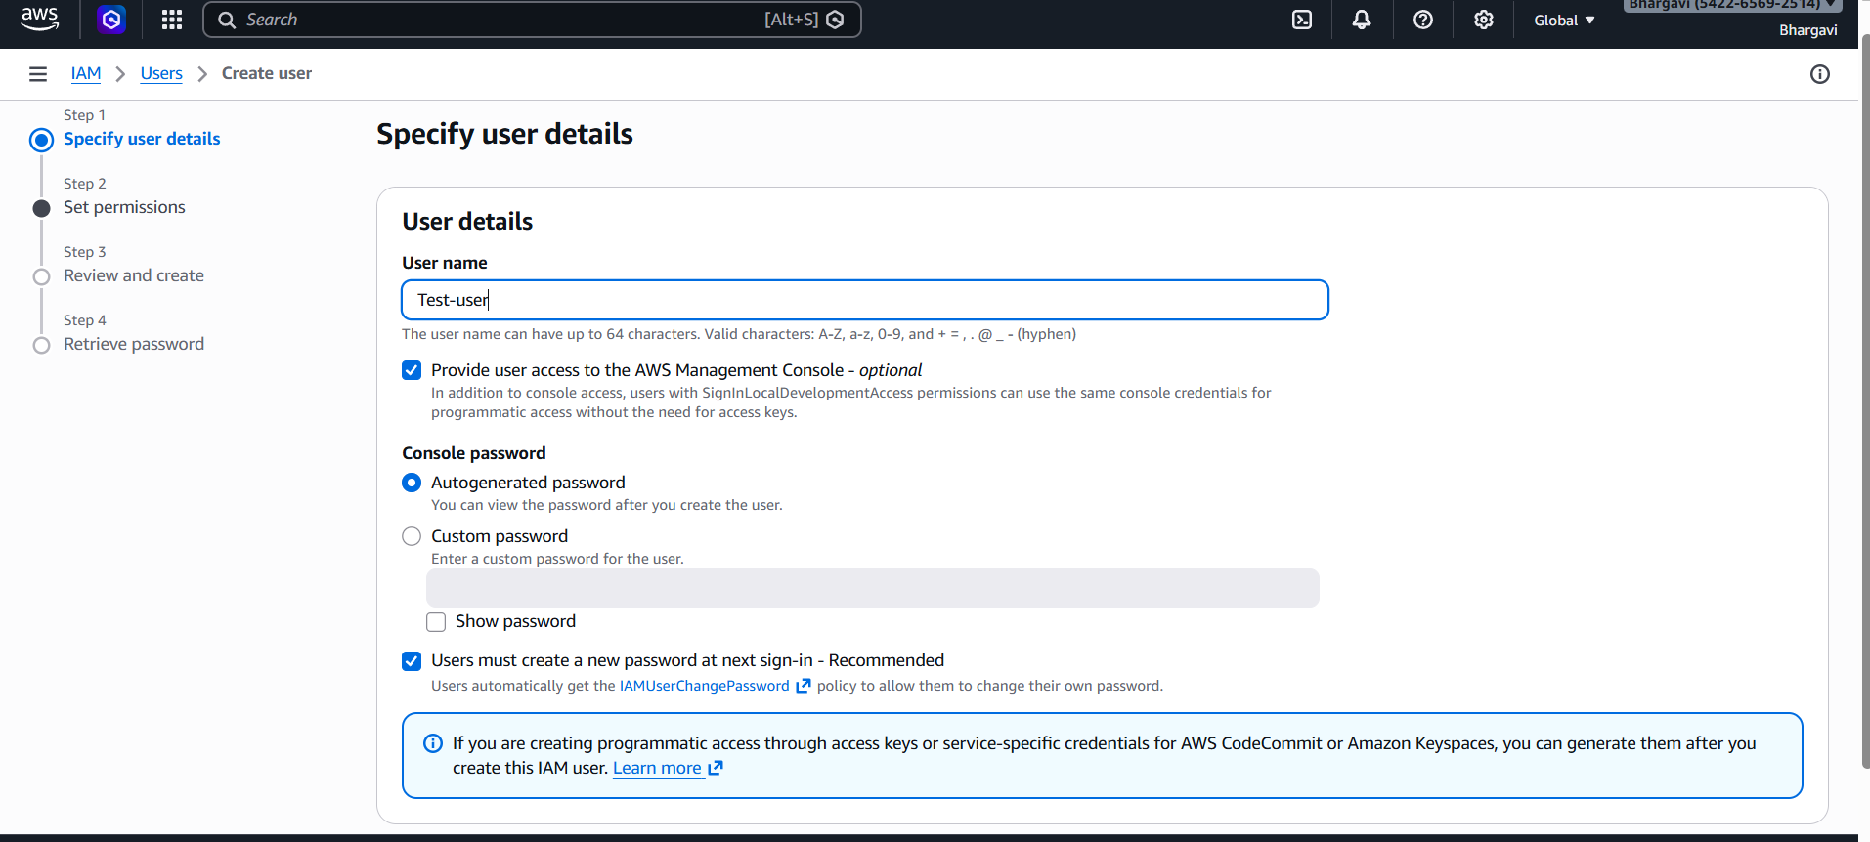
I have enabled AWS Management Console access
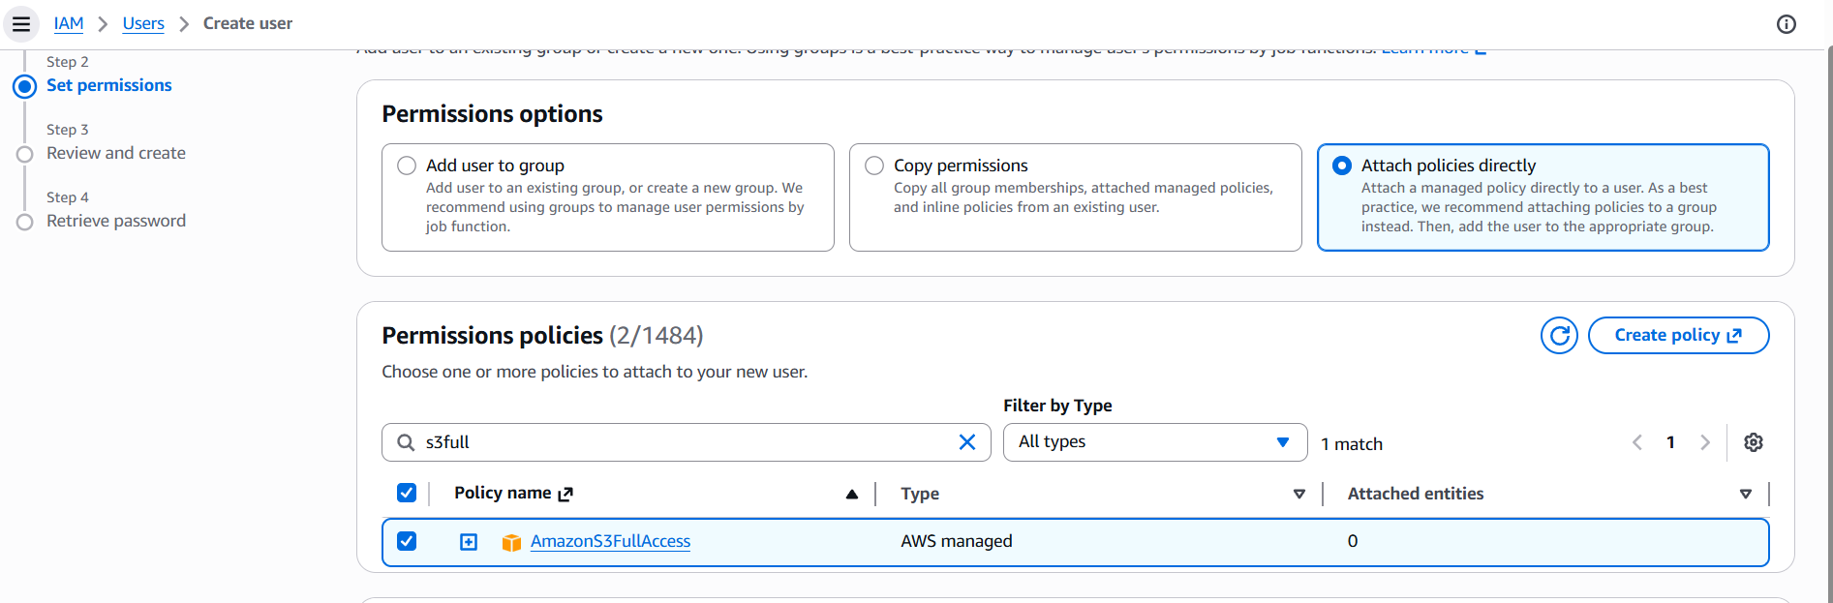
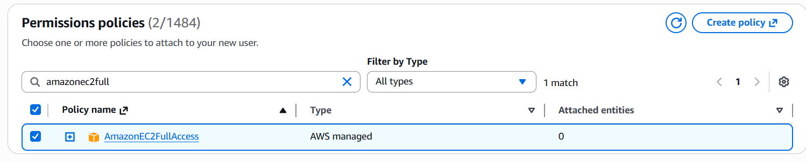
Set Permissions
- Select Attach policies directly
- Search and attach the following policies:
S3fullaccess
Ec2fullaccess
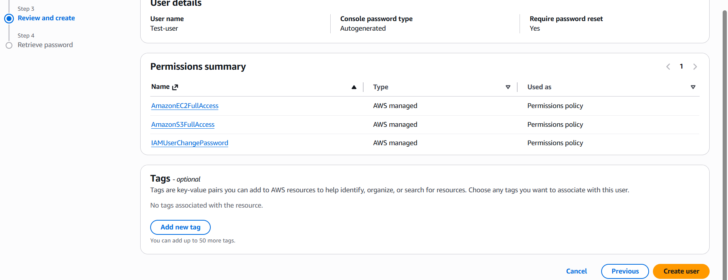
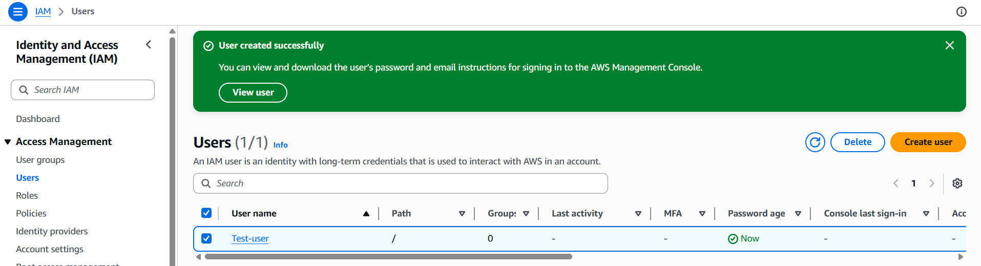
2. Create one group in IAM and assign read access for EC2.
Created a new group and attached it to the group and gave only read
access for EC2.
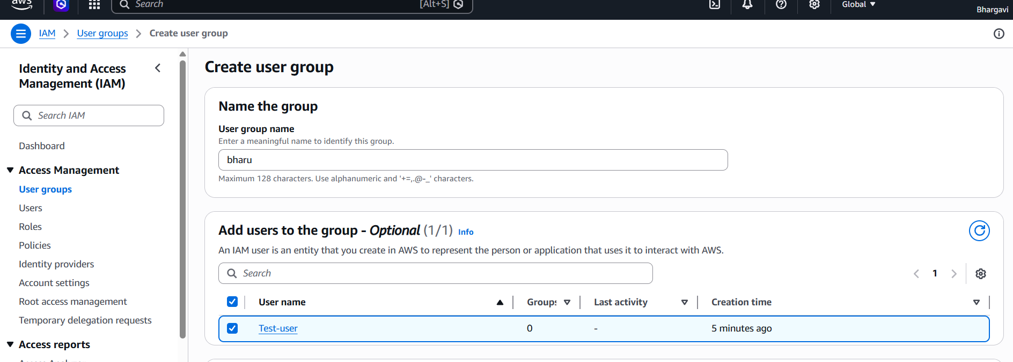
In IAM Dashboard → Click User Groups
- Click Create group
- Enter group name
-Attach Permissions
1. Under Attach permissions policies
2. Search and select:
o AmazonEC2ReadOnlyAccess
This policy allows users to:
- View EC2 instances
- Check instance status
- View configurations and resources
- Cannot create, modify, or delete resources
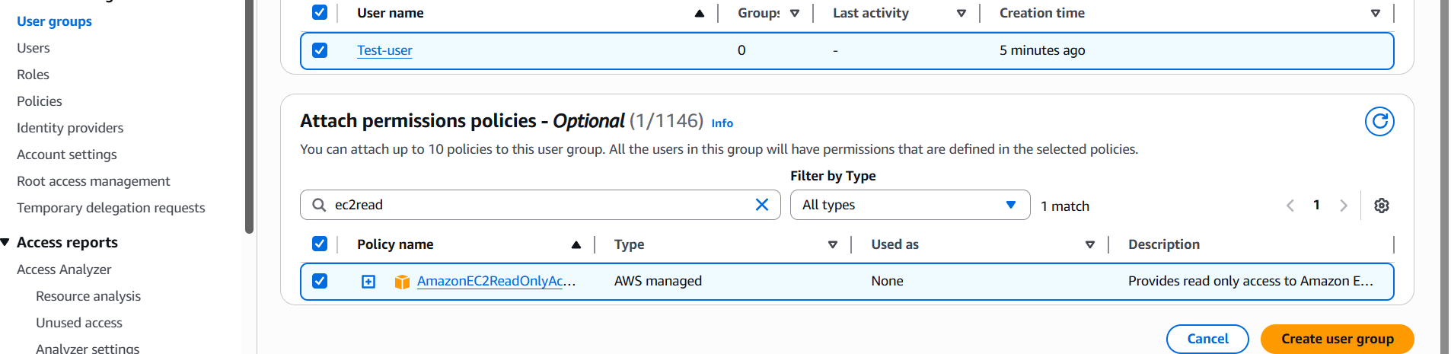
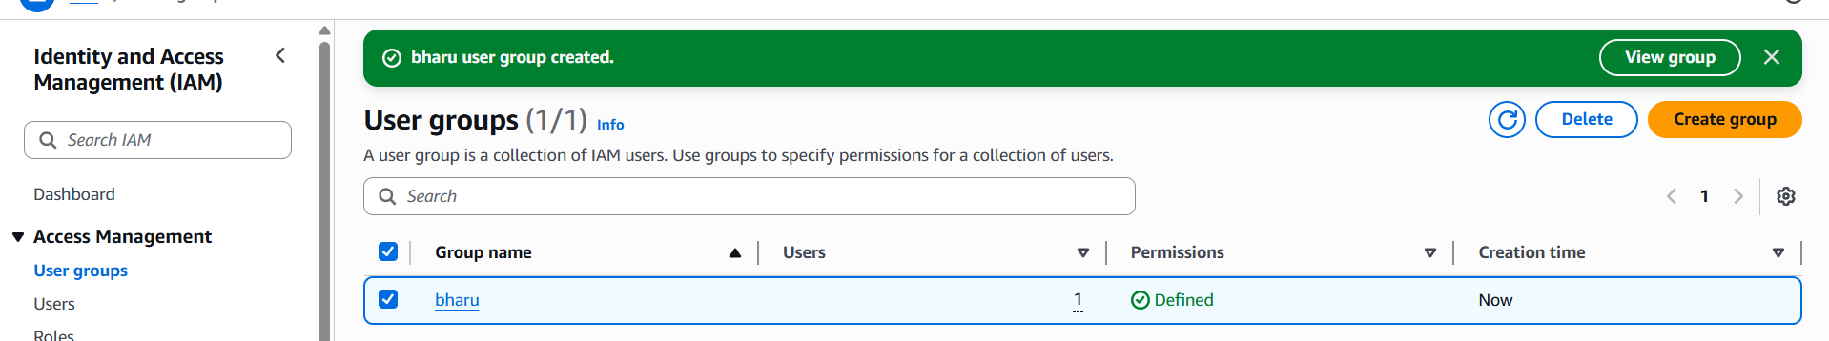
3.Create a new user named "Devops" and add to the group created in task 2.
Create New IAM User
- In IAM Dashboard → Click Users
- Click Create user
- Enter username: Devops

Here I am adding user to the existing group
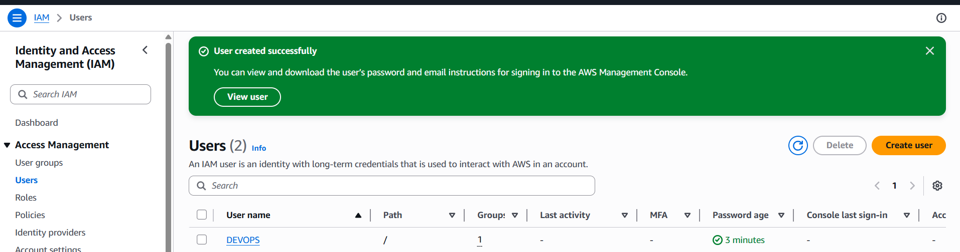
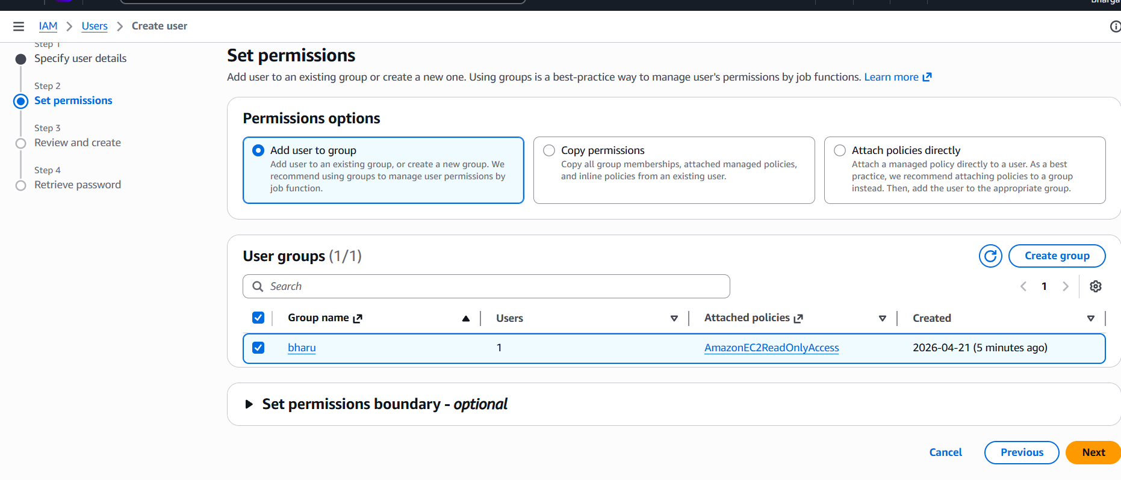

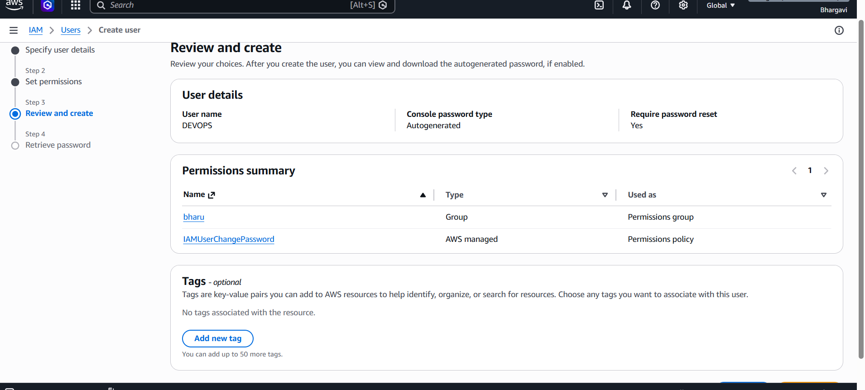

4. Write a bash script to create an IAM user with VPC full access.
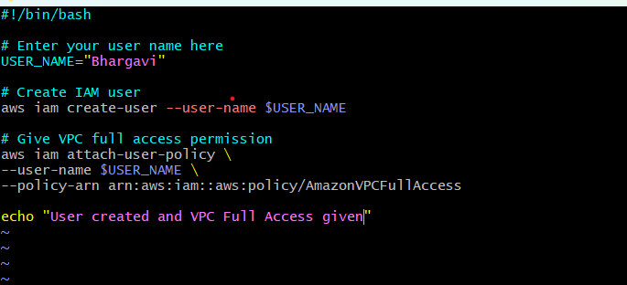
I have created a file and wrote a bash script to create an IAM user with VPC full access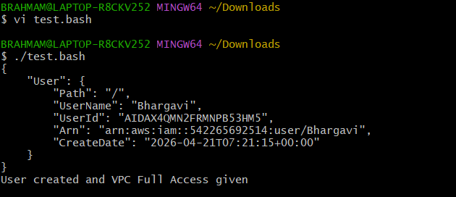
Now I have checked that user was added or not.
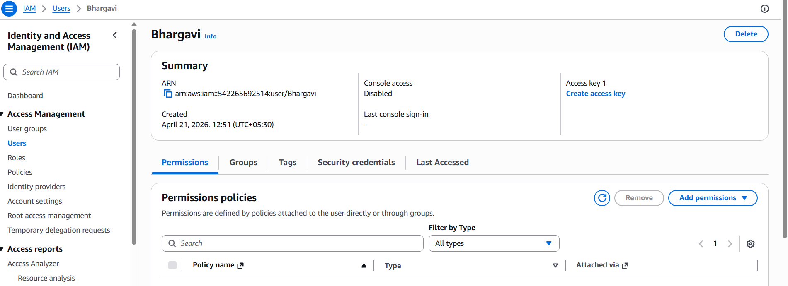
5.Create an IAM policy to allow EC2 access for a specific user in specific regions only.
First I have created policy
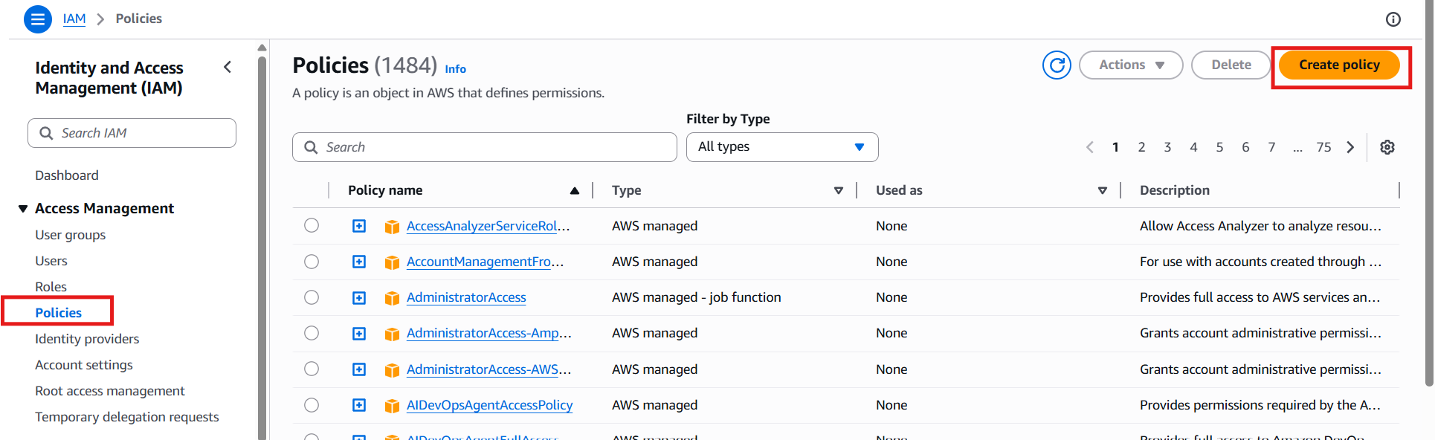
I have added json policy
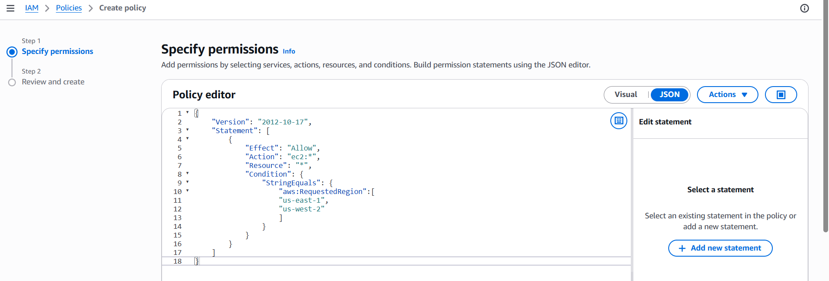
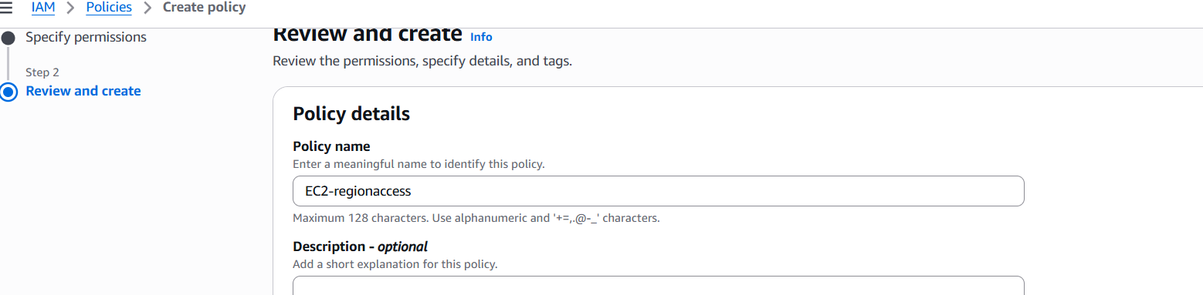
-verify the policy
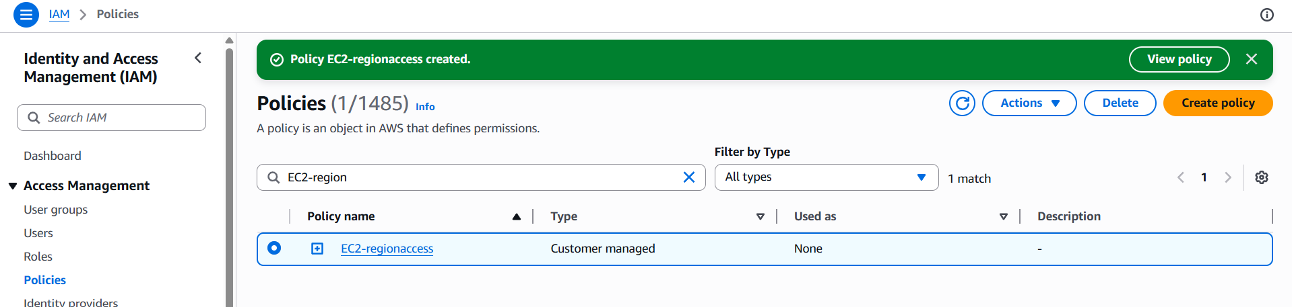
-Added policy to the user I have created
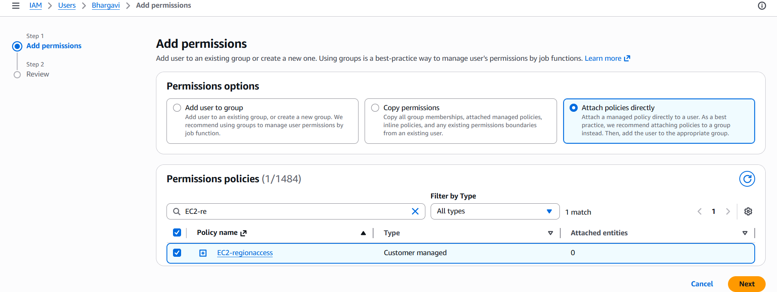
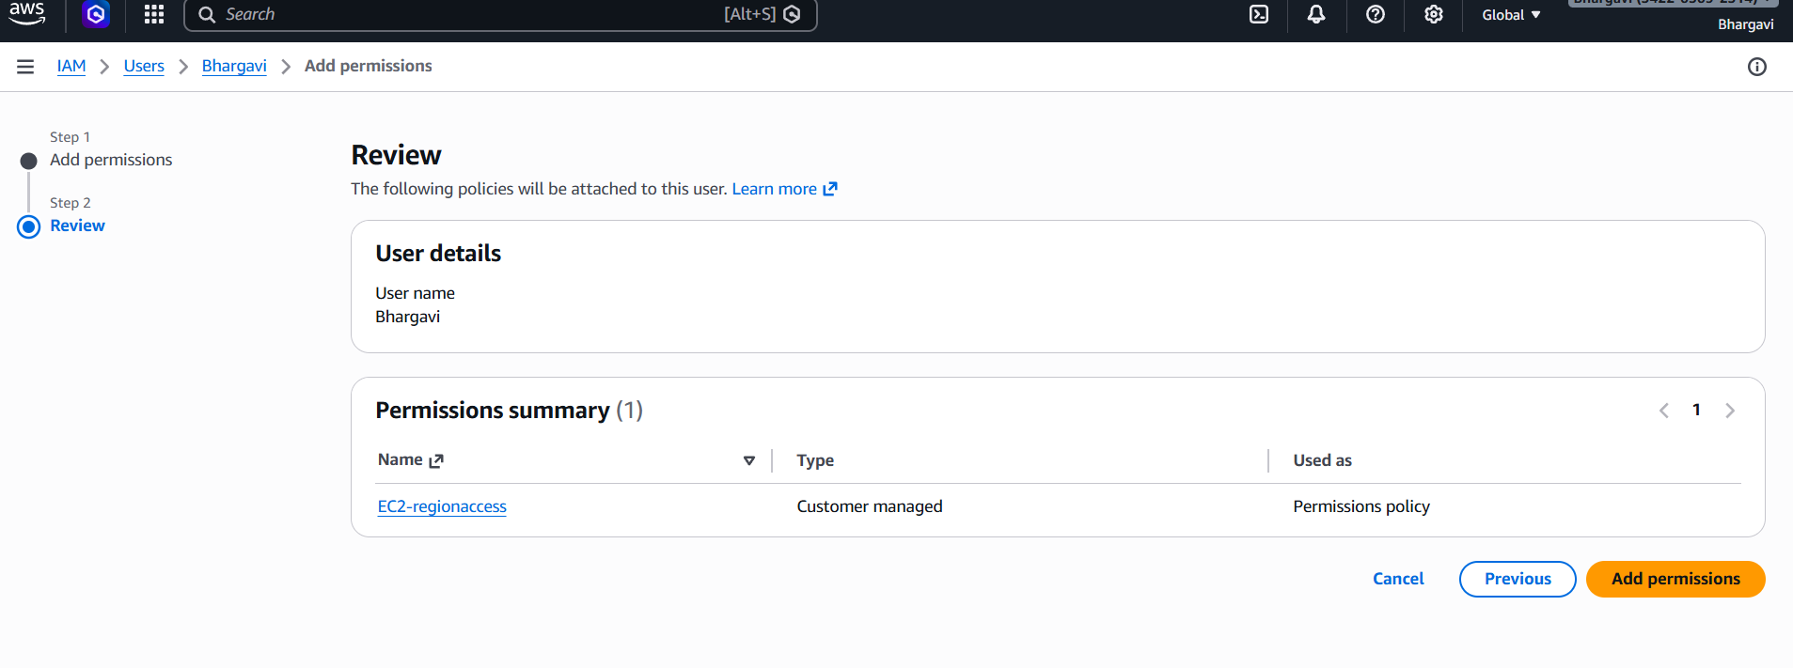
->successfully added our policy
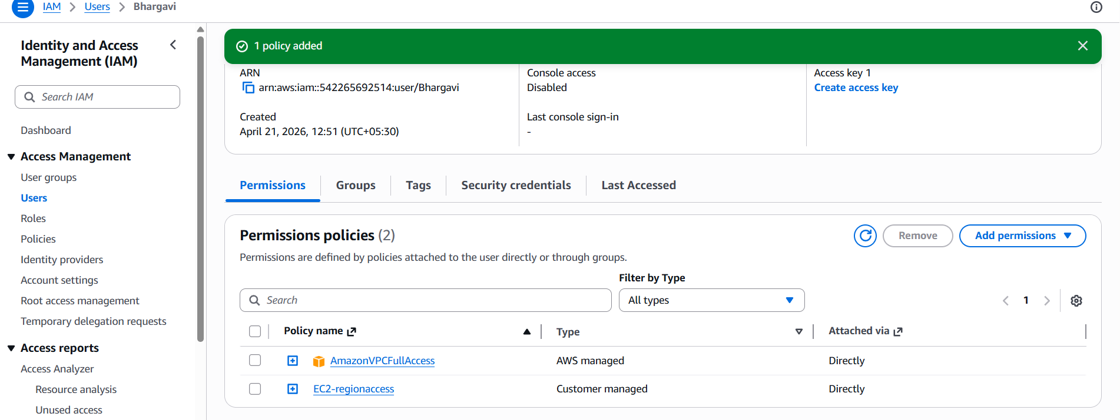
6.We have two accounts: Account A and Account B. Account A user should access an S3
bucket in Account B.
go to amazon S3Bucketscreate bucket name amzw-s3-bucket-bv(my name or any unique name will be give)create bucketthen go to add anyfiles in that file and folders we can see our files

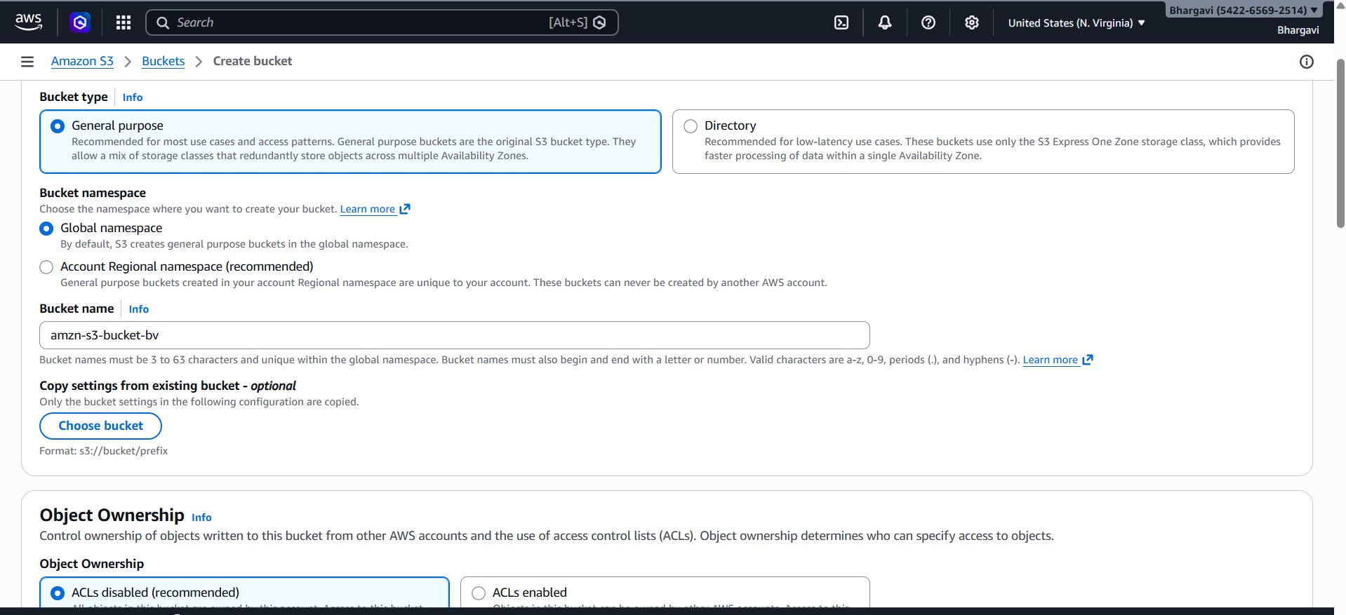
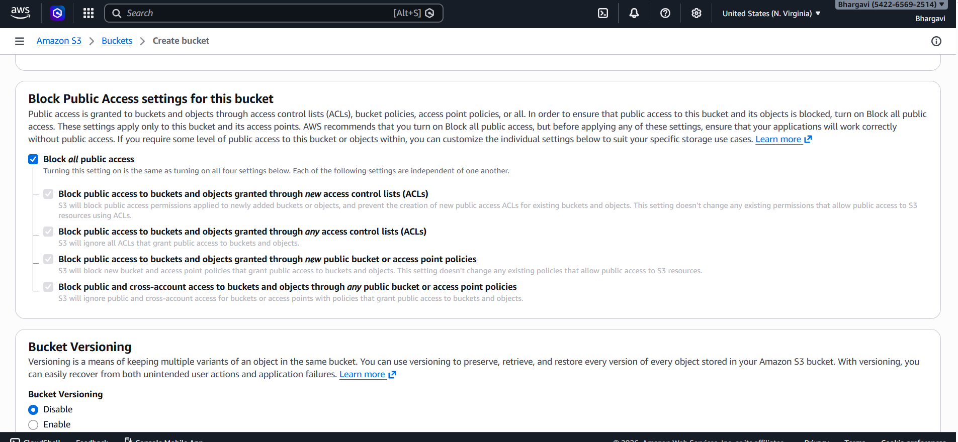
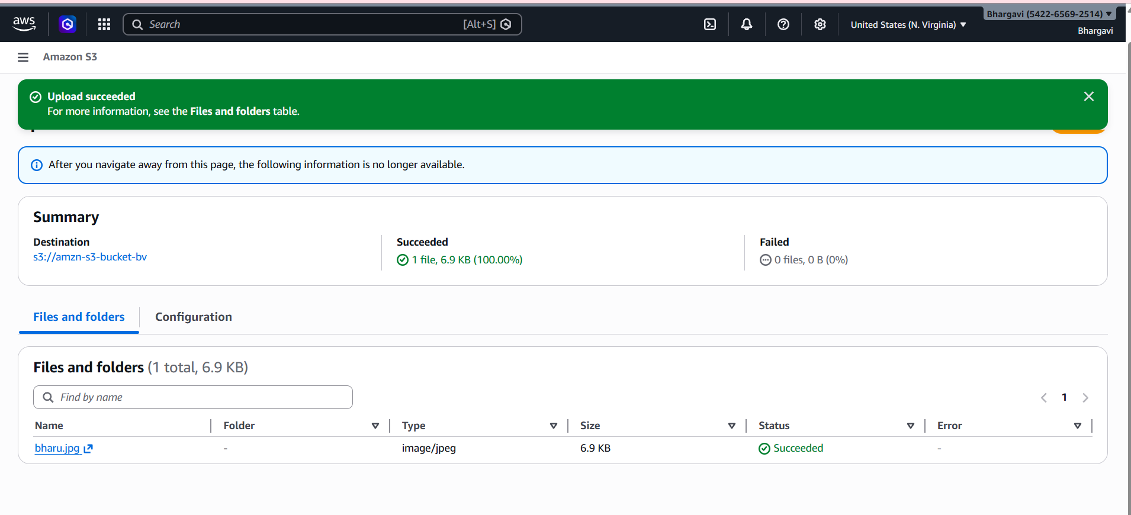
go to permissionseditscroll down
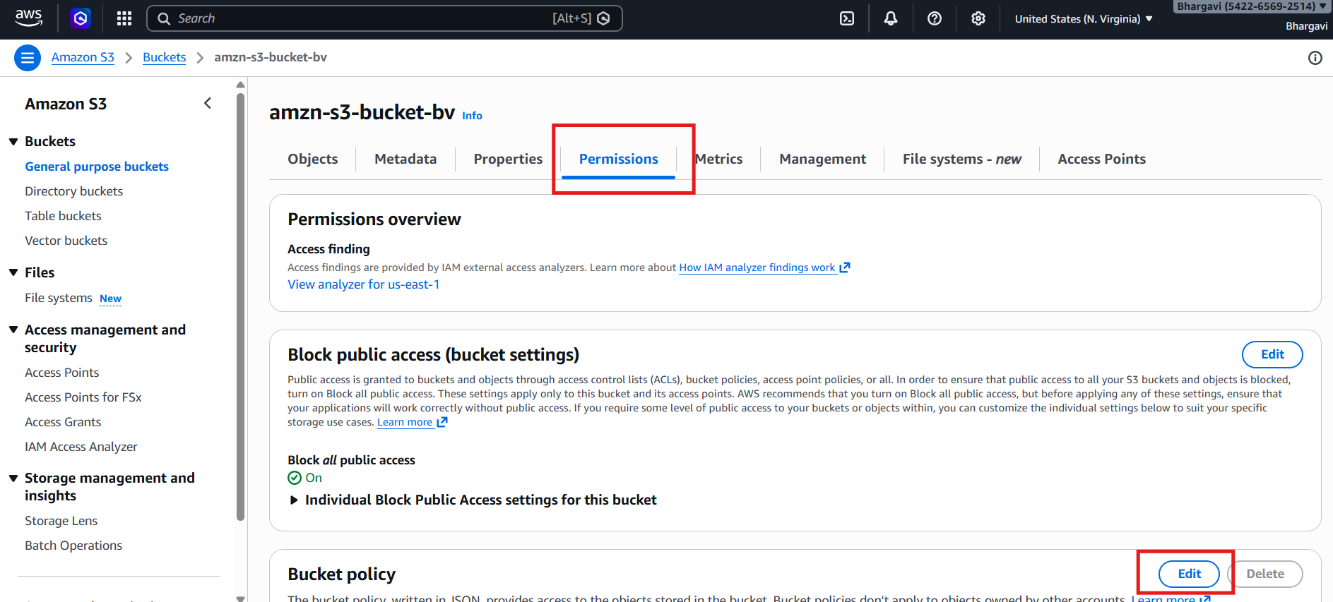

I have added policy to allow account b sony to access my bucket
in this 1st we can give sony user idin last line I want to give my bucket arn number.-->I able to acces by bucket in sony git bashshe will configure with their access keys and password aws s3 ls s3://amzn-s3-bucket-bv ….>here I can see my bucket as been showed in her git bash.
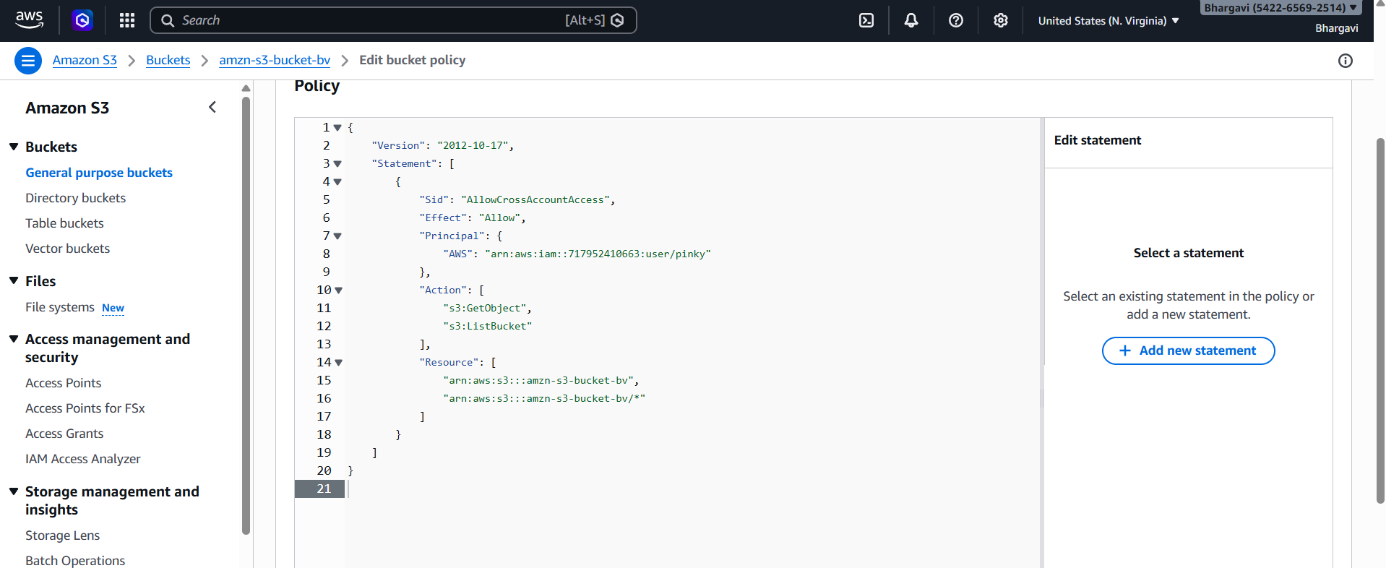
Now sony account is able to access by bucket
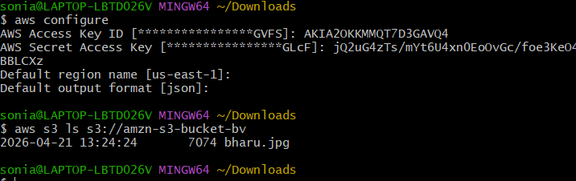
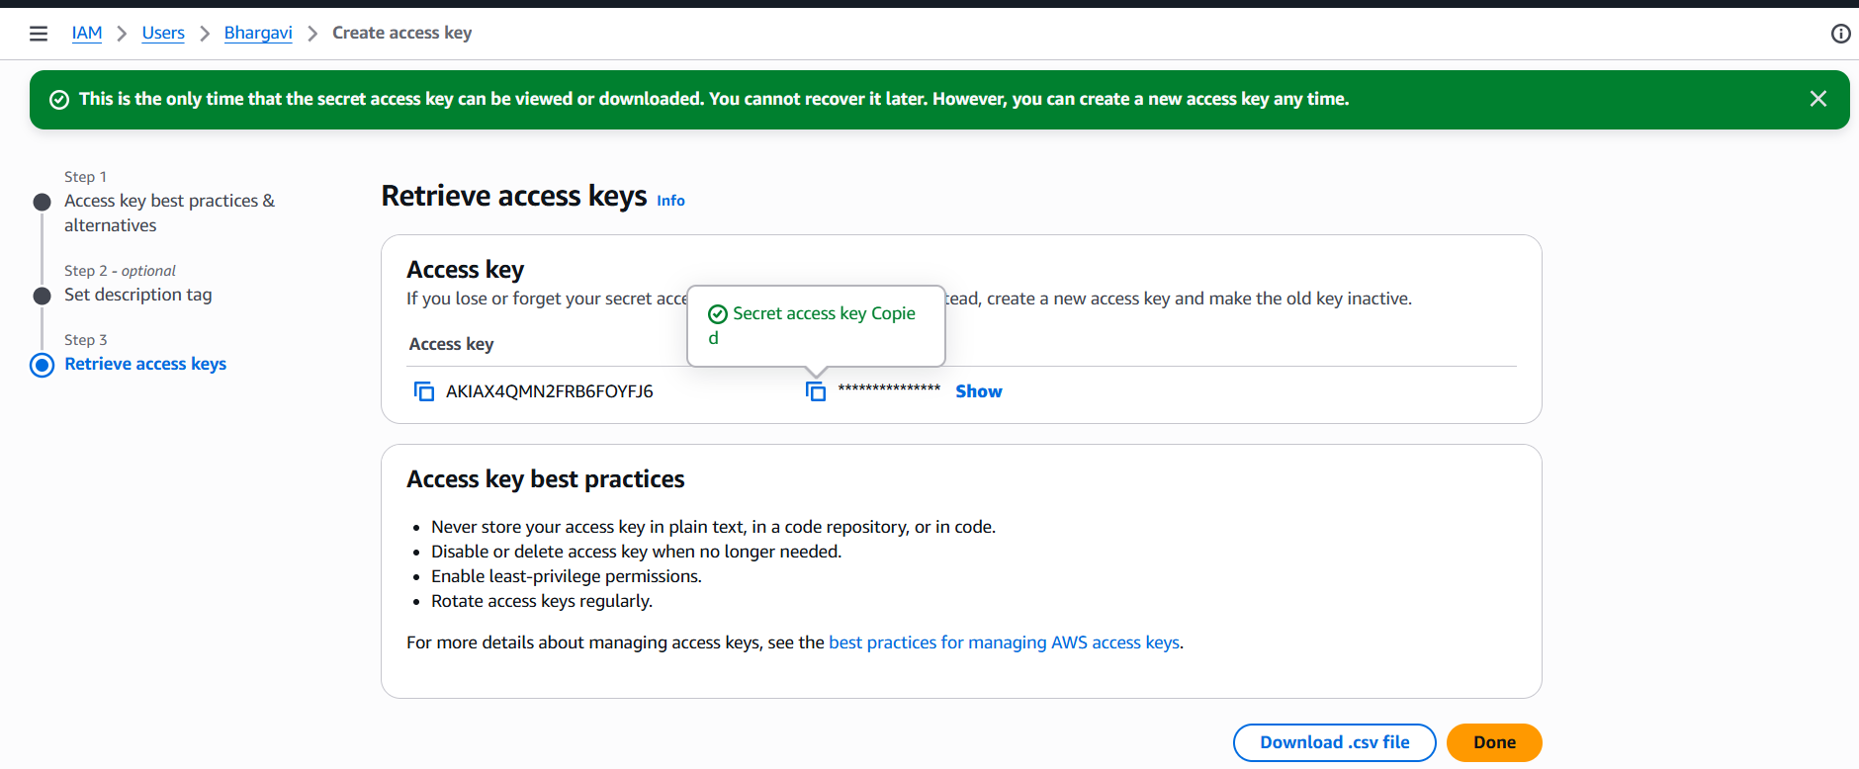
Now I want to able sony account
